DC Compact Service Manual

**CONTENTS**

1. Security Compliance 1

2. Terms and Abbreviations 1

3. Technical Specification 2

3.1 Screw Torque Table 2

3.2 List of Maintenance Tools 4

4. System Introduction 5

4.1 Product Overall (Outside) 5

4.2 Product Overall (Inside) 7

5. Maintenance Requirements 8

5.1 General Maintenance Requirements 8

5.2 Enclosure Maintenance Requirements 9

5.3 Power Circuit Maintenance Requirements 9

5.4 Gaskets Maintenance Requirements 10

5.5 Cable Maintenance Requirements 10

5.6 Residual Current Circuit Breaker 11

6. Disassembly and Reassembly Steps 13

6.1 Charging Cable 14

6.2 POS Device 15

6.3 Screen 16

6.4 Filter 17

6.5 PCBA 18

6.6 Charging modules 19

6.7 RCCB and AC contactor 20

6.8 DC Contactor 21

6.9 Auxiliary Power Supply 22

7. Revision History 23

# Security Compliance

Disconnect the power supply to the MaxiCharger during the entire maintenance procedure.

* The load capacity of the grid must meet the requirements of the MaxiCharger.
* Connect the MaxiCharger to a grounded, metal, permanent wiring system. Otherwise, use the equipment-grounding conductor with the circuit conductors and connect it to the equipment grounding terminal or lead on the product.
* Unqualified personnel must keep a safe distance during the entire maintenance procedure.
* The connections to the MaxiCharger must comply with all applicable local rules.
* Only use electrical wires of sufficient gauge and insulation to handle the rated current and voltage demand.
* Protect the wiring inside the MaxiCharger from damage and do not obstruct the wiring when you perform maintenance on the cabinet.
* Keep the cabinet away from all water source.
* Protect the MaxiCharger with safety devices and measures as specified by local rules.
* Wear proper personal protective equipment such as protective clothing, safety gloves, safety shoes, and safety glasses when necessary.

Refer to “MaxiCharger DC installation and Operation Manual” for more details.

# Terms and Abbreviations

|  |  |  |
| --- | --- | --- |
| No. | Abbreviations | Detailed Description |
| 1 | AC | Alternative Current |
| 2 | ALM | Adaptive Load Management |
| 3 | BMS | Battery Management System |
| 4 | CAN | Controller Area Network |
| 5 | CCS | Combined Charging System |
| 6 | CCU | Communication Control Unit |
| 7 | CHAdeMO | trade name of a fast-charging system for battery electric vehicles |
| 8 | CPU | Central Processing Unit |
| 9 | DC | Direct Current |
| 10 | DLB | Dynamic Load Balancing |
| 11 | DNS | Domain Name System |
| 12 | DPA | Dynamic Power Allocation |
| 13 | DTC | Diagnostic Trouble Code |
| 14 | ECU | Electronic Control Unit |
| 15 | ELCB | Earth Leakage Circuit Breaker |
| 16 | FPGA | Field Programmable Gate Array |
| 17 | FW | Firmware |
| 18 | GFCI | Ground Fault Circuit Interrupter |
| 19 | IMU | Isolation Measurement Unit |
| 20 | MAC | Media Access control |
| 21 | MCB | Miniature Circuit Breaker |
| 22 | MCCB | Molded Case Circuit Breaker |
| 23 | MCU | Main Control Unit |
| 24 | NFC | Near Field Communication |
| 25 | OBD | On-Board Diagnostics |
| 26 | OCPI | Open Charge Point Interface |
| 27 | OCPP | Open Charge Point Protocol |
| 28 | OS | Operating System |
| 29 | PCB(A) | Printed Circuit Board (Assembly) |
| 30 | PLC | Programmable Logic Controller |
| 31 | PME | Protective Multiple Earthing |
| 32 | POS | Point of Sale |
| 33 | PWM | Pulse-width Modulation |
| 34 | RCBO | Electromagnetic type residual current operated circuit -breaker with integral overcurrent protection |
| 35 | RCCB | Residual Current Circuit Breaker |
| 36 | RCD | Residual Current Device |
| 37 | RFID | Radio-Frequency Identification |
| 38 | SIM | Subscriber Identity Module |
| 39 | SOC | State Of Charge |
| 40 | SOH | State Of Health |
| 41 | SPD | Surge Protective Device |
| 42 | SPI | Serial Peripheral Interface |
| 43 | TCU | Transmission Control Unit |
| 44 | USB | Universal Serial Bus |
| 45 | VCI | Vehicle Communication Interface |
| 46 | VtoG | Vehicle to Grid |

# Technical Specification

## Screw Torque Table

Control board (M3 screws, torque value 5.5 ± 10% kgf.cm) , copper busbar (M4 screws, torque value 12 ± 10% kgf.cm ;M6 screws, torque value 12 ± 10% kgf.cm; M8 screws, torque value 70 ± 10% kgf.cm; M10 screws, torque value 120 ± 10% kgf.cm), circuit breaker (The specific value is subject to the recommended torque value that comes with the part. If there is no recommended value, please refer to the following Table 1 for General Connection 2.), charger wire, DC contactor (M8 screws. The specific value is subject to the recommended torque value that comes with the part. If there is no recommended value, please refer to the following Table 1 for General Connection 2.), fan (M4 screws, torque value 12 ± 10% kgf.cm) and screen (M4 screws, torque value 12 ± 10% kgf.cm)

Table 1 Torque Wrench Calibration Table (Unit: kgf.cm)

|  |  |  |  |
| --- | --- | --- | --- |
| Screw Spec. | General Connection | | |
| 1 | 2 | 3 |
| Steel (direct tapping, counter tapping) and die-cast aluminum | Steel (rivet nut or bolted joint) | Aluminum, copper and plastic |
| M2 | 1.5 | 1.5 | 0.8 |
| M2.5 | 3 | 3 | 1.6 |
| M3 | 5 | 5.5 | 3 |
| M4 | 10 | 12 | 6 |
| M5 | 13 | 20 | 10 |
| M6 | 28 | 30 | 15 |
| M8 | 65 | 70 | 35 |
| The values in this table are recommended values when the strength rating of the screw (nut) is 4.8 (≥ 6), the yield strength is greater than 200 MPa for the direct tapping base steel plate and greater than 175 MPa for other aluminum materials, and the selected die-cast aluminum is ADC12.  When the materials of the two connecting materials are different, the corresponding value of the one with the lower material strength should be selected.  Torque tolerance is ±10%. | | | |

Adjust the torque to an appropriate level according to the diameter of the screws and nuts when screwing fasteners with an electric screwdriver to avoid damage to the cross groove of the screws. The adjustment basis is shown in Table 2.

Table 2 Correspondence between Electric Screwdriver Screwing Force and Fastener

|  |  |  |  |  |
| --- | --- | --- | --- | --- |
| Screw | Torque Range (kgf.cm) | Body Weight (Kg) | Body Length (mm) | Flexible Shaft Diameter (mm) |
| M2 | 2-5 | 0.27 | 196 | 6.35 |
| M3 | 5-10 | 0.42 | 231 |
| M4 | 8-16 | 0.57 | 245 |
| M5 | 16-28 | 0.70 | 257 |
| M6 | 35-55 | 1.05 | 253 |

## List of Maintenance Tools

|  |  |  |  |
| --- | --- | --- | --- |
| Multi-meter |  | Screwdriver  (type T25) |  |
| Screwdriver  (type T10) |  | Shifting Wrench |  |
| Screwdriver (PH2) |  | Safety Shoes |  |
| Safety Gloves |  | Wire Stripper |  |
| Wire Cutter |  | Crimping Tool |  |
| Heat Gun |  | Heat Shrink Tubing |  |
| Suction Cup |  |  |  |

Electric screwdriver or Phillips screwdriver, torque wrench/socket wrench (5.5 mm (M3 hexagon screw), 7 mm (M4 hexagon screw), 10 mm (M6 hexagon screw), 13 mm (M8 hexagon screw), 16 mm (M10 hexagon screw)), suction cup (quantity: 2; used for replacement of TCU assembly)

# System Introduction

## Product Overall (Outside)

1. 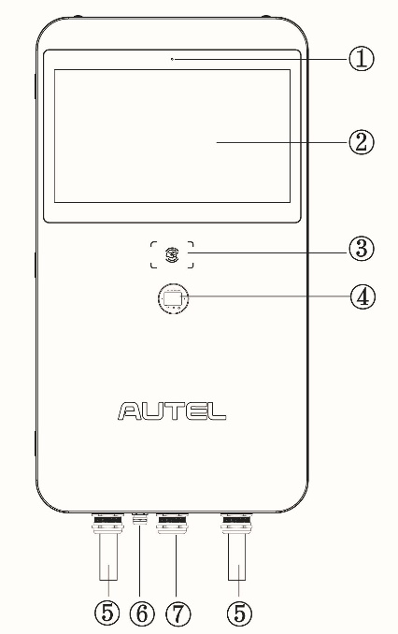Light Sensor
2. Touchscreen
3. RFID Card Reader
4. POS Payment Device (optional)
5. EV Charging Cable
6. Ethernet Cable Port
7. AC Inlet Hole
8. Vent — each on the right and left side
9. Slot
10. Groove
11. Bezel
12. Lifting Handle

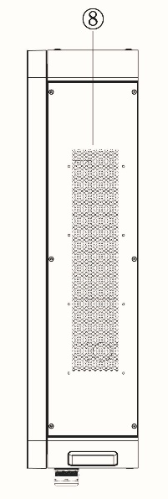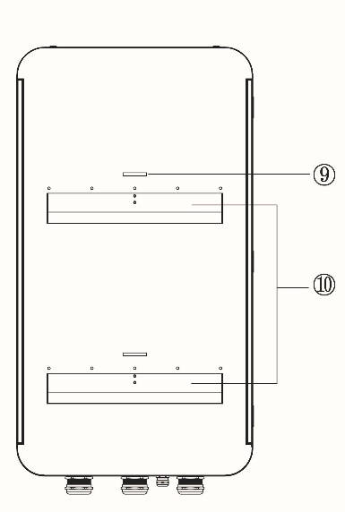

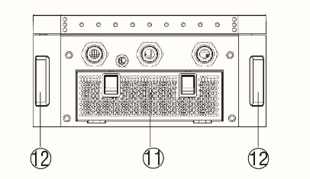

EU DC Compact Overall Layout (Outside)

1. Ambient Light Sensor — detects ambient brightness
2. 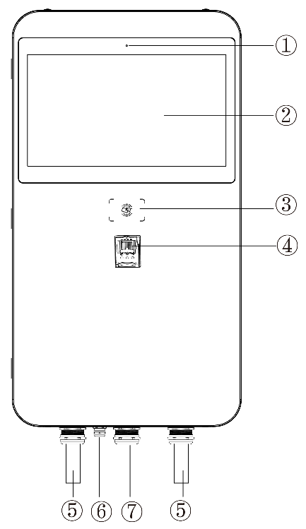21.5-inch LCD touchscreen
3. RFID Reader
4. POS Device (Optional)
5. Charging Cable
6. Ethernet Cable Inlet Hole
7. AC Inlet Hole
8. Vent — each on the right and left side
9. Mounting Metal Plate
10. Groove
11. Inlet Air Filter
12. Lifting Handle

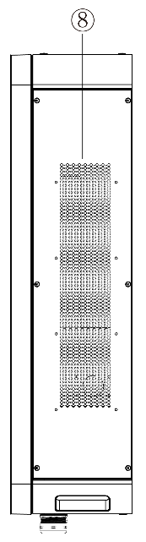US DC Compact Overall Layout (Outside)

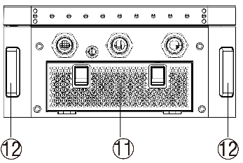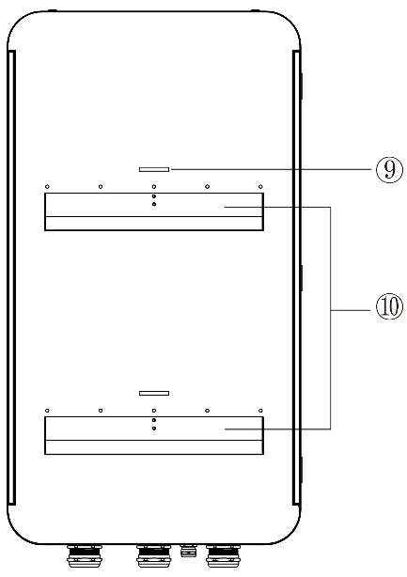

## Product Overall (Inside)

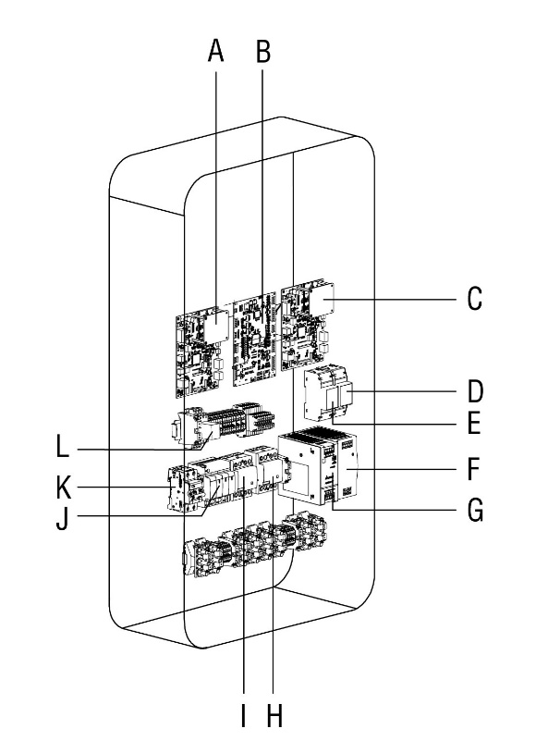

|  |
| --- |
| 1. Inertial Measurement Unit 1 |
| 1. Electronic Control Unit |
| 1. Inertial Measurement Unit 2 |
| 1. Energy Meter (PJ1) |
| 1. Energy Meter (PJ2) |
| 1. 48 V Auxiliary Power |
| 1. 24 V Auxiliary Power |
| 1. AC Contactor (KM2) |
| 1. AC Contactor (KM1) |
| 1. Surge Protection Device |
| 1. Fuse |
| 1. Intermediate Relay |

EU DC Compact Overall Layout (Inside)

|  |  |
| --- | --- |
| **A** | Electronic Control Unit |
| **B** | Inertial Measurement Unit 1 |
| **C** | Intermediate Relay |
| **D** | Fuse |
| **E** | SPD, Surge Protective Device |
| **F** | AC Contactor 1 |
| **G** | AC Contactor 2 |
| **H** | Inertial Measurement Unit 2 |
| **I** | Energy Meter 2 |
| **J** | Energy Meter 1 |
| **K** | 48 V Auxiliary Power |
| **L** | 24 V Auxiliary Power |
|  |  |

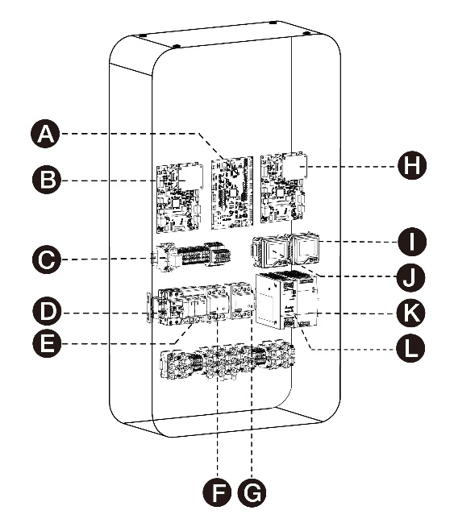US DC Compact Overall Layout (Inside)

# Maintenance Requirements

## General Maintenance Requirements

Periodic maintenance must be established in order to obtain the best service from the EVSE charger. An annual check of the switchgear devices and all connections should be the minimum requirement. Equipment subject to highly repetitive operation may require more frequent maintenance. A permanent record of all maintenance work should be kept. The record should include a list of periodic checks and tests made, the date they were made, the condition of the equipment, and any repairs or adjustments that were performed. Maintenance employees must follow all recognized safety practices, such as those contained in the National Electric Safety Code and in company or other safety regulations. For specific information regarding the maintenance of devices, such as AC contactor, RCCB, relays, meters, etc, refer to the separate instruction book provided for each device.

## Enclosure Maintenance Requirements

The enclosure station requires no maintenance other than occasional cleaning.

Warning: To reduce the risk of electrical shock or equipment damage, do not allow opening the unit while cleaning it. Enclosure maintenance is performed only externally.

Clean the enclosure using a soft cloth lightly moistened with mild detergent solution.

Never use any type of abrasive pad, scouring powder, or flammable solvents such as alcohol or benzene.

## Power Circuit Maintenance Requirements

Inspection of the power circuit is recommended at least once a month. More frequent inspections are recommended if several load conditions, dust, moisture, or other unfavorable conditions exist.

• RCCB

If the breaker remains open or closed for a long period of time, it is recommended that arrangements be made to open and close it several times in succession, preferably under load.

At all times, it is important not to permit paint, oil or other foreign materials to remain on the insulating surfaces or the breaker as they may cause low resistance between points of different potential and result in eventual electrical breakdown.

Always inspect the devices after a short circuit current has been interrupted.

Normally, the over current protective device on the circuit will prevent any electrical damage except at the actual point of the short circuit.

A thorough inspection of the entire system must be made after any large fault current to insure that there has been no mechanical damage to conductors, insulation, or equipment.

Do not open sealed devices such as breaker trip units. If there is any possibility that sealed units may have been damaged, they should be replaced.

At the time of inspection, the following checks should be made after the device has been de-energized.

- Manually operate the device several times checking for obstructions or excessive friction.

- Electrically operate the device several times (if breaker has electrical control) to ascertain whether the electrical attachments are functioning properly.

- Break-age of parts or extensive burning will indicate need for replacement.

- Check operation of tripping devices, including over current trip devices, making sure all have positive tripping action. (Discernible movement in tripping direction beyond point of tripping).

- Push test-button in the RCCB device: positive tripping action (ensure RCCB device is powered, therefor the RCCB should be closed manually).

• AC Contactor

Ensure a trouble free operation of the contactor until the next service is required. As in the previous devices, always inspect the device after main breaker tripping. At the same time, observations can be made to judge if the contactor operates well in the application.

Ensure that electrical continuity in all the poles is retained and should be operable in ON/trio/rest sequence manually. If there is any possibility the unit has been damaged, it should be replaced. For additional details on the particular device, refer to the applicable instruction manual provided with the device.

• Impulse Surge Arrester

The surge arresters do not contain wearing parts and therefor, they are maintenance free.

Replacement parts are not needed. Maintenance is based into a visual inspection of the following parts:

- Check that the arrester housing is clean and free from where is installed.

- The monitoring device for leakage current (Fault indicator) is reviewed as it is indicated.

It is recommended to replace the units that caused the mechanically defect of the surge arrester.

## Gaskets Maintenance Requirements

Gaskets require regular maintenance to prevent mold and mildew and to maintain the elasticity of the seal. Visually check the different gaskets or lid for tears or punctures. Leaks are indicated by a streak of frost that forms at the point of gasket failure.

Gasket and retainer groove cleaning can be accomplished with the use of warm soapy water and a soft bristle brush.

CAUTION: Avoid full strength cleaning products on gaskets as this can cause them to become brittle and prevent proper sealing. Never use sharp tools or knives to scrape or clean the gasket. This could tear the gaskets.

## Cable Maintenance Requirements

Inspect and check the cables as follows:

• Inspect all power cable connections for signs of overheating and tighten all connections.

• If severe discoloration or if damage is apparent, remove the damaged cable and replace any device with damaged terminal.

• Check the neutral bus and earth bus connection and mounting bolts for tightness.

• Check that all wiring connections are tight and all control cabling is intact.

CAUTION: Be sure the condition which caused the overheating has been corrected before reenergizing.

## Residual Current Circuit Breaker

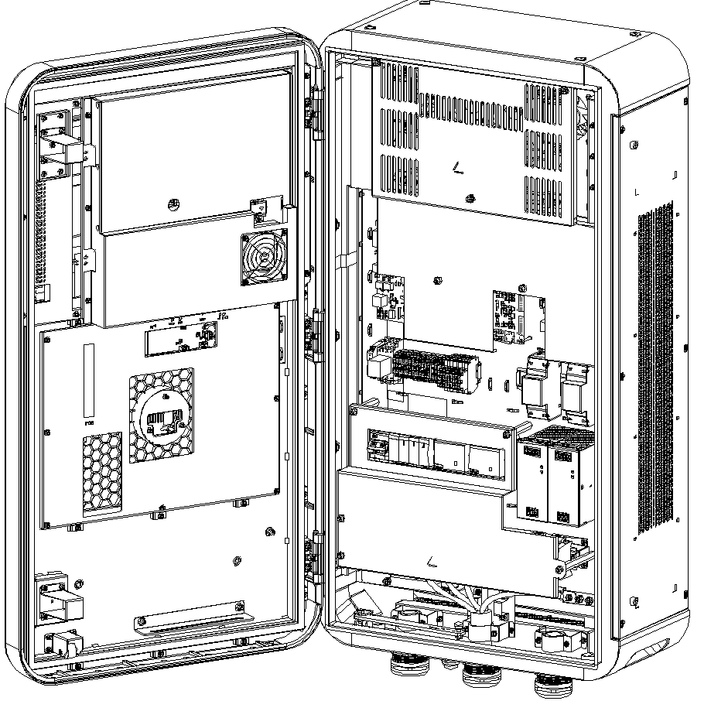 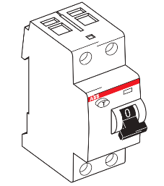

RCCB

Steps to remove RCCB:

1. Disconnect the front circuit breaker of the charging pile and cut off the power supply of the charging pile;

2. Open the front door of the charging pile, and remove the RCCB front cover as shown in the figure;

3. Use a screwdriver to curve the connection cable of RCCB;

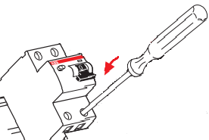 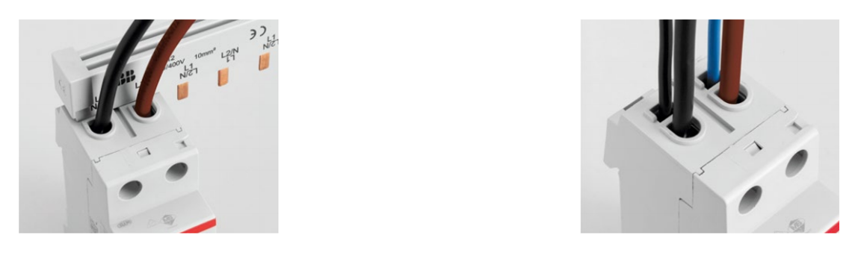

4. Use a screwdriver to pull out the buckle at the bottom of the RCCB and remove the RCCB.

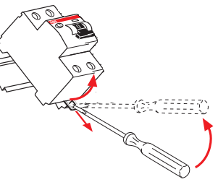

Steps to install RCCB:

1. Install the RCCB on the guide rail according to the diagram;

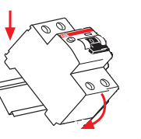

2. Connect the wire harness to the corresponding port of the RCCB according to the wire harness identification;

 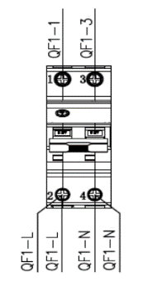

3. Restore the front cover of the RCCB and close all the doors of the charging pile;

4. Turn on the front-stage circuit breaker of the charging pile, connect the power supply, and wait for the charging pile to start before it can be used.

RCCB (model: F202A 25/0.03) parameters are as follows:

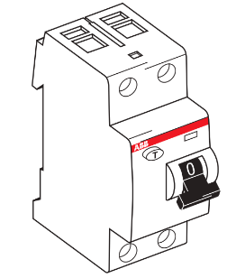



# Disassembly and Reassembly Steps

Important:

To ensure that the charger is powered off, the upstream circuit breaker/isolating switch of the charger must be cut off for component replacement. At the same time, the auxiliary power supply circuit breaker of the charger must be cut off.

Discharge static electricity before removing the cables and dismantling the components.

## **Charging Cable**

① Loosen screws of the AC connector, PE bar, terminal and bracket.

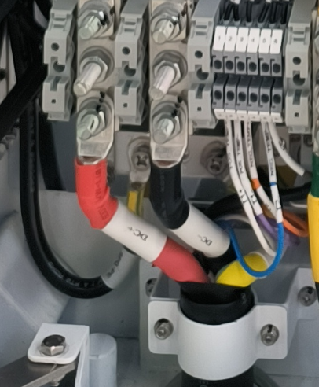

Bracket

PE Busbar

Control Cable

AC Connector

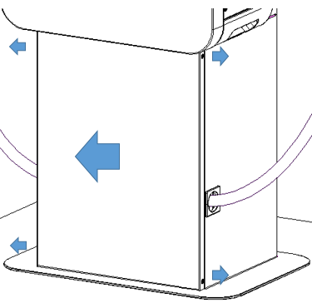

③ Loosen the cable gland.

② Loosen the lower two security screws of the pedestal and remove the lower front cover.

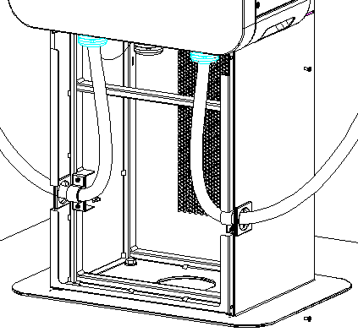

④ Unscrew the bracket on the side of the pedestal and pull out the cable.

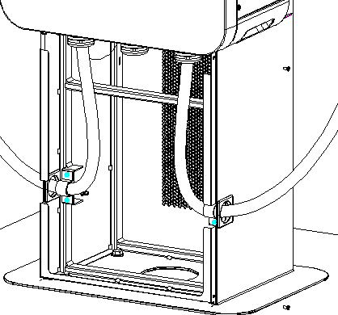

⑤ Follow the reverse steps to install a new charging cable.

## POS Device

① Remove the cable from the POS device.

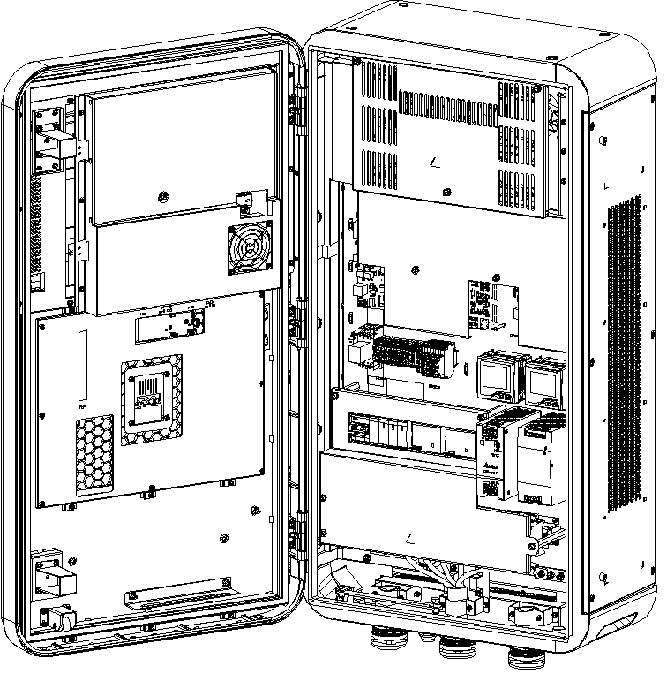

EU US

② For EU version, unscrew the M4 (3 pcs) nuts securing the POS device using the 7mm socket.

For US version, unscrew the M5 (3 pcs) screws securing the POS device using the screwdriver..

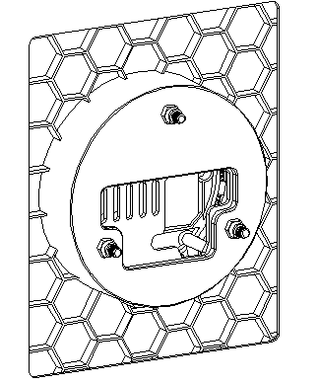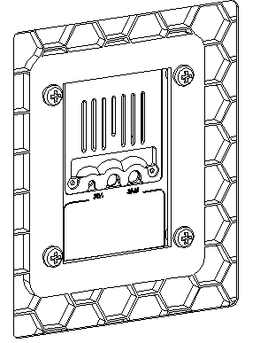

EU US

③ Remove the POS device from the front side of charger.

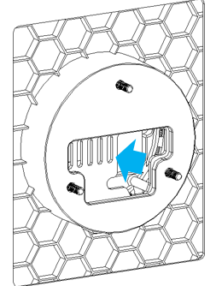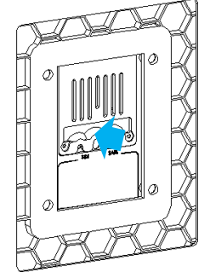

EU US

⑤ Follow the reverse steps to install a new POS device.

## Screen

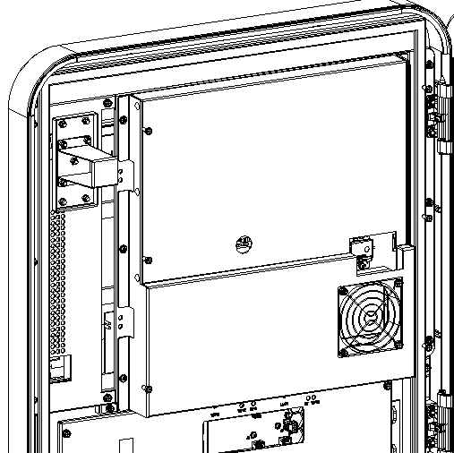

②.Remove POS device ( Optional) following the steps above.

①.Unscrew the M4 screws (6 pcs) of the PC cover on the back of screen using screwdriver

③ Remove Photoelectric Sensor, Backlight cable, LVDS cable, TP FPC, heating film cable and NFC board.

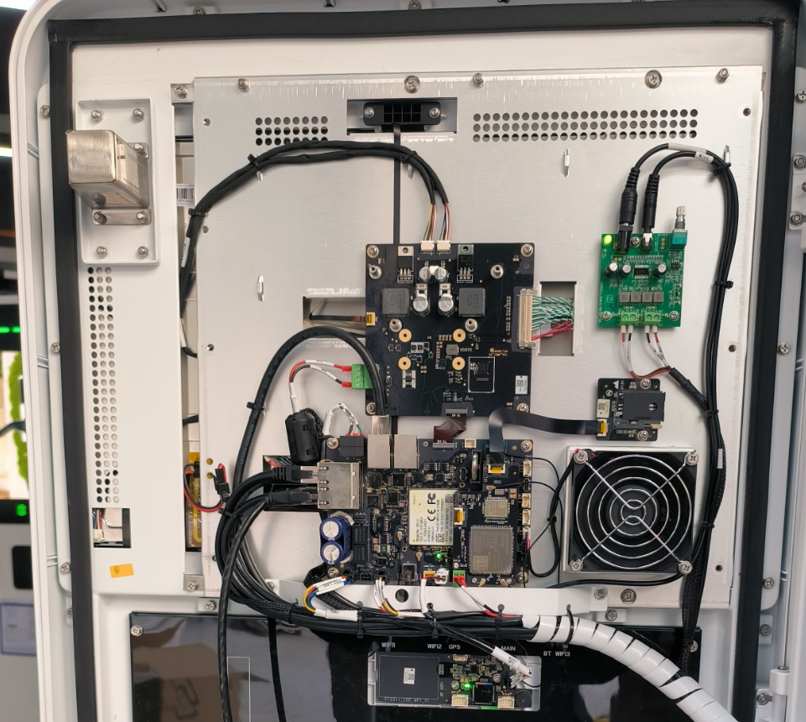

NFC Board

Heating Film Cable

TP FPC

LVDS Cable

Backlight Cable

Photoelectric Sensor

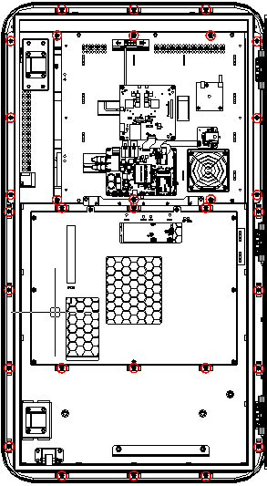

④.Unscrew the faceplate securing screws using screwdriver and remove the faceplate ( Including the screen).

⑤.Follow the reverse steps to install a new faceplate ( Including the screen).

## Filter

①.Open the two toggle latches (A) at the bottom of the MaxiCharger to flip the bezel (B) downward.

②.Remove the filter (C).

③.Clean debris or dust of the filter and reinstall a cleaned filter.

④.Install a new air filter.

⑤.Flip the bezel (B) upwards and close the two toggle latches (A).

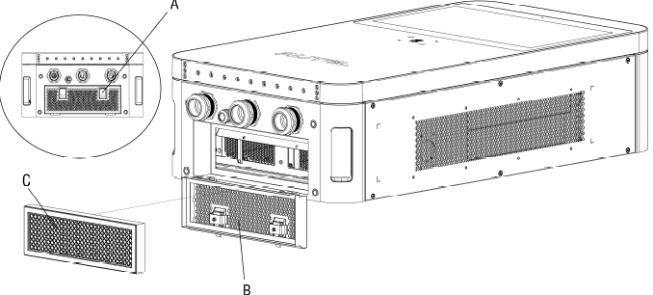

## PCBA

① Remove the wires on the PCBA

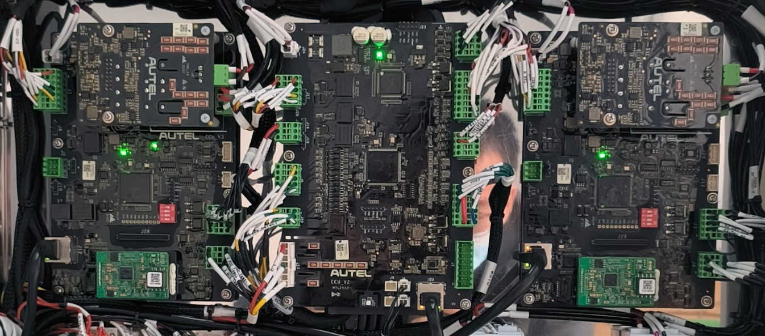

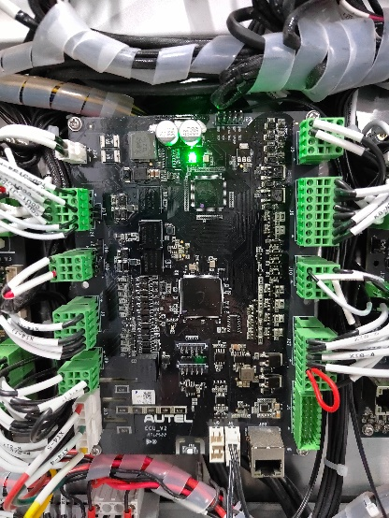

③ Replace a new PCBA following the reverse steps.

② Unscrew the securing screws and remove the PCBA.

## Charging modules

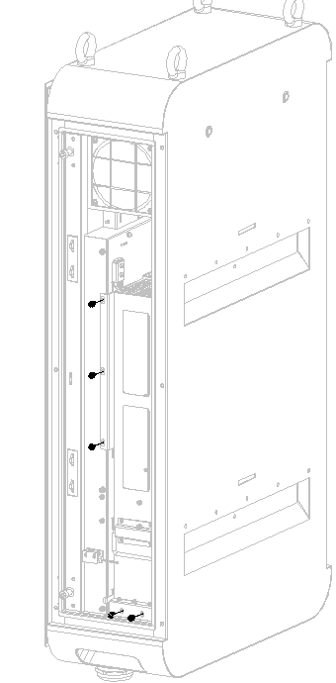 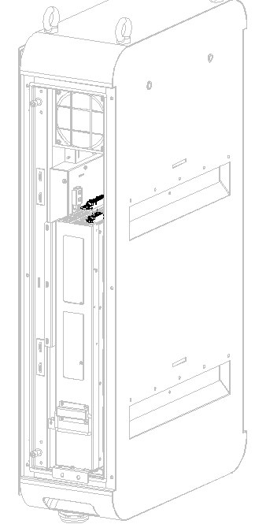

①. Remove the securing screws (M4) outside.

②. Pull the module assembly to the limit and remove the cable.

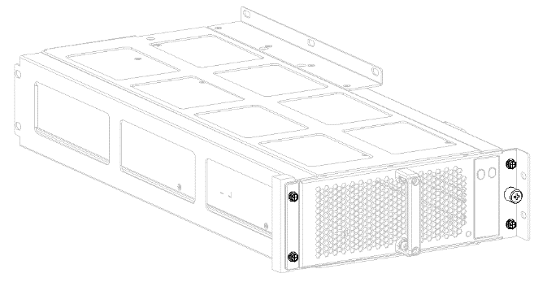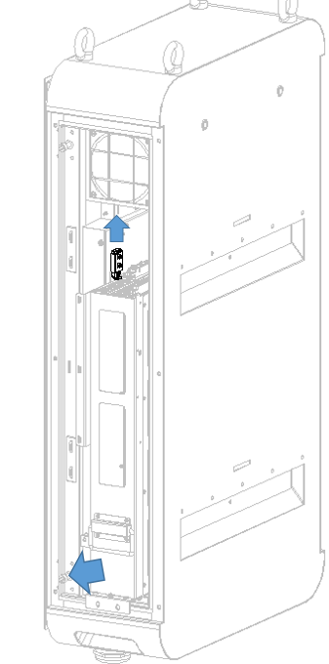

③.Pull the module assembly up and pull it out.

④. Remove the securing screws at bottom, then take out the module.

## RCCB and AC contactor

RCCB

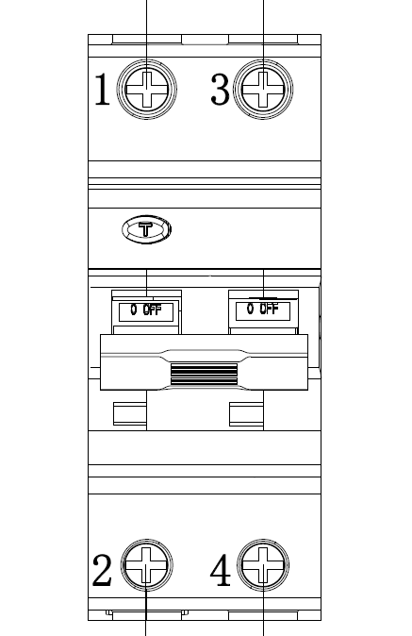 

②.Pull the buckle down to remove the device from the rail.

①.Remove the cables from the terminals.

AC Contactor

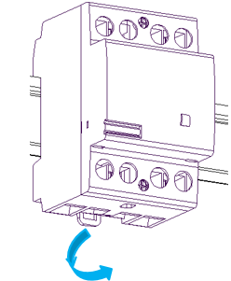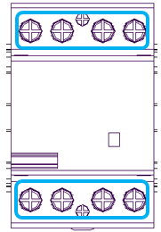

①.Remove the cables from the terminals.

②.Pull the buckle down to remove the device from the rail.

## DC Contactor

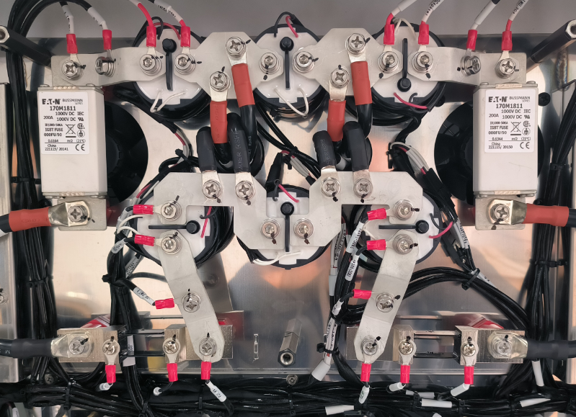

①.Remove the cables from the DC contactor.

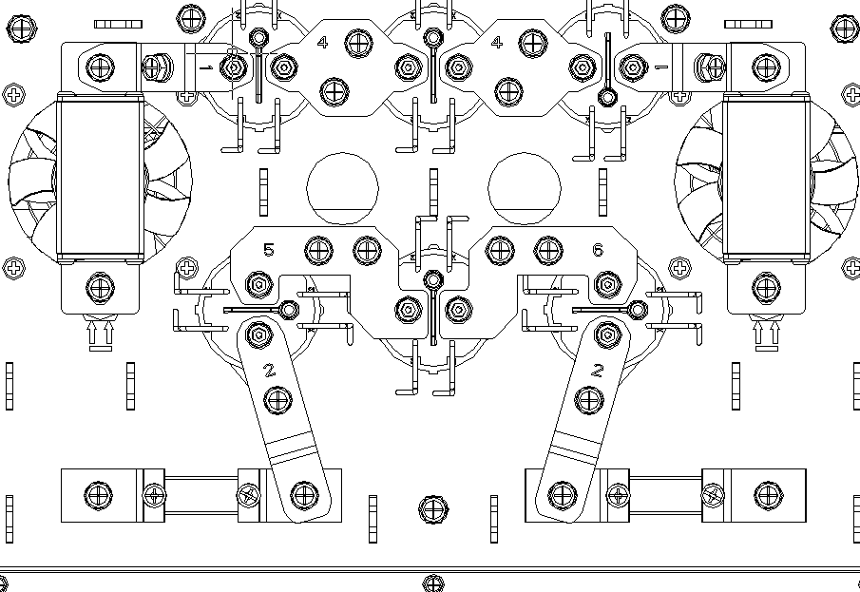

②.Remove the copper bar above the DC contactor.

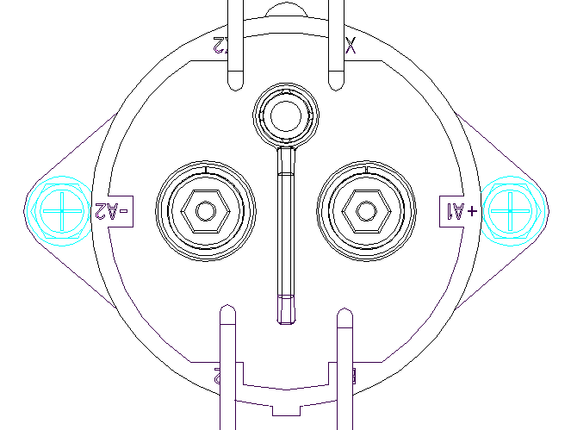

③.Unscrew the two securing screws at bottom of the DC contactor.

## Auxiliary Power Supply

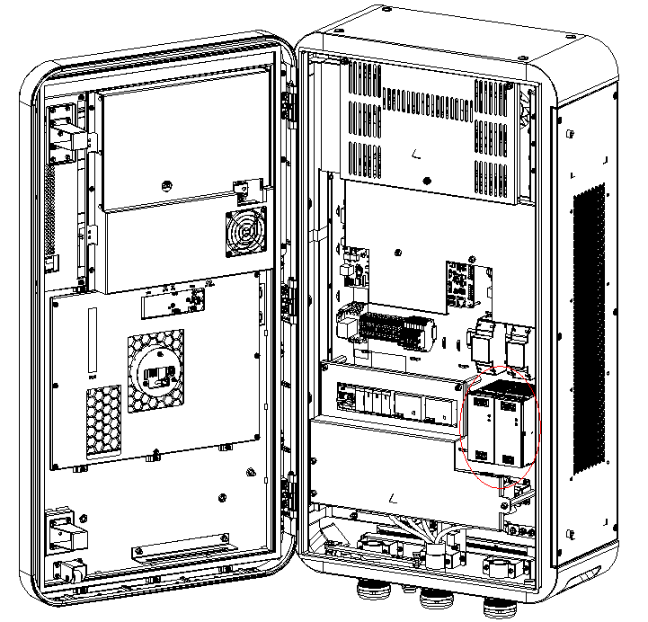 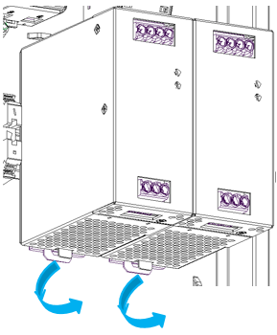

②.Pull the buckle down to remove the device from the rail.

①.Remove the cables from the auxiliary power supply.



# Revision History

|  |  |  |
| --- | --- | --- |
| Version | Date | Descriptions |
| V1 | 2022.10.20 | Initial version |
| V1.1 | 2023.04.13 | Model updated  5.6 Residual Current Circuit Breaker updated. |